OS - post midsem:
Memory management: Managing memory efficiently
Stages of compilation:
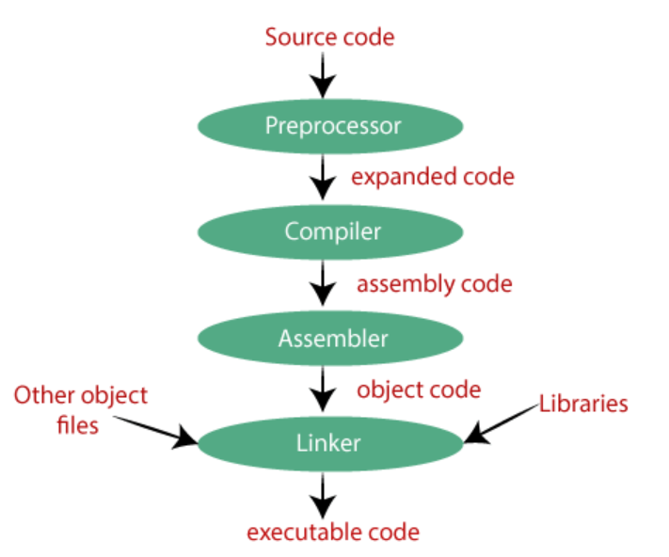
Preprocessing: source code to expanded source code
It performs tasks such as including header files, expanding macros, and removing comments.
Includes files: If your code needs some other files (like libraries), the preprocessor adds them. For example, when you use #include <stdio.h>, it brings in the code from that file.
Expands macros: If you've used shortcuts like #define PI 3.14, it replaces PI with 3.14 everywhere in your code.
Compilation: expanded source code to assembly code
example assembly code:
mov eax, [ebp+8]
add eax, [ebp+12]
mov [ebp-4], eax
mov eax, [ebp-4]

Assembler: assembly code to object code

Linker:
These library functions are pre-compiled, and the object code of these library files is stored with '.lib' (or '.a') extension. The main working of the linker is to combine the object code of library files with the object code of our program.
The output of the linker is the executable file (.exe)
Header files (stdio.h) typically contain declarations (like function prototypes) and doesn’t include the actual implementation or machine code for these functions. The actual machine code (or object code) for functions like printf is stored in compiled library files, not in header files.
Loader:
Loads the executable file from secondary memory to main memory to execute

Static linking:
Static linking combines all the parts of a program, including libraries, into one single executable file.
Benefit: There is no runtime dependency on any external libraries.
Dynamic linking:
Instead of including all library code in the executable, the linker adds "stub" for the libraries. During runtime, when the program runs, these stub check if the library is already in memory(main memory). If not, the program loads the library as needed.
Benefit: This saves memory

Static loading:
Loaded Executable file contains all the necessary libraries.
Dynamic loading:
stub loads the required library files if they are not present in main memory.

Degree of multiprogramming is directly proportional to CPU utilisation.
Because if a particular process that is running in the CPU goes to waiting state because of I/O operation, then another process in the ready queue can enter into CPU for its execution.
internal fragmentation:
For example, if a process requires 80 KB of memory and is allocated a partition of 100 KB, there will be 20 KB of unused space within that partition. This unused space is internal fragmentation.
external fragmentation:
External fragmentation occurs in a free memory block when there is enough available memory for a new process to run, but the available space is divided into small non-contiguous blocks.

Contiguous memory allocation:
Entire program is stored at one place (no spanning)
Eg:
Fixed partition
Variable partition
Fixed partition – internal fragmentation
memory is divided into fixed number of partitions.
first fit, next fit, best fit
Both internal and external fragmentation
Variable partition - external fragmentation
in variable partition, generally there are no partitions and processes are arranged continuously. Now consider some processes left the memory for execution. Now available space is divided into small non-contiguous blocks. So external fragmentation.
Compaction technique is used to overcome external fragmentation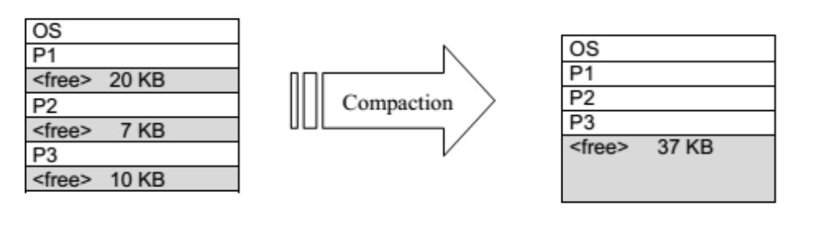
It is only possible in dynamic reallocation i.e processes can change their memory addresses
Not always easy to perform compaction.
A huge amount of time is wasted in performing compaction.

Overlay:
Generally comes in fixed size partition.
Sometimes it happens that compare to the size of the biggest partition, the size of the program will be even more, then, in that case, you should go with overlays
Then overlays concept says that whatever part you required, you load it and once the part is done, then you just unload it and get the new part you required and run it and these parts are known as overlays.
(each part is independent of one another)
The idea behind overlays is to only load the necessary parts of a program into memory at a given time. The unused portions of the program are kept on disk or other storage, and are loaded into memory as needed.

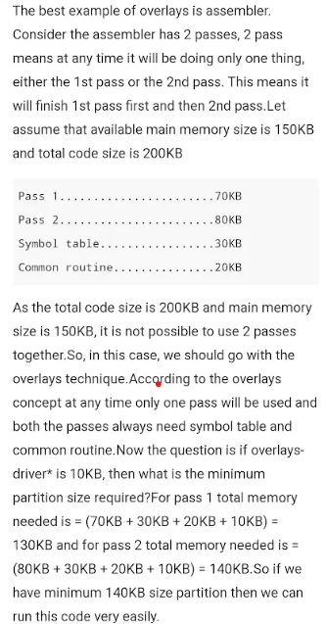
Overlays driver :
Overlay driver is responsible for loading and unloading of appropriate overlays into the main memory as needed. in each pass, some memory is allocated in the main memory to the overlay driver along with the overlay to facilitate its operation.
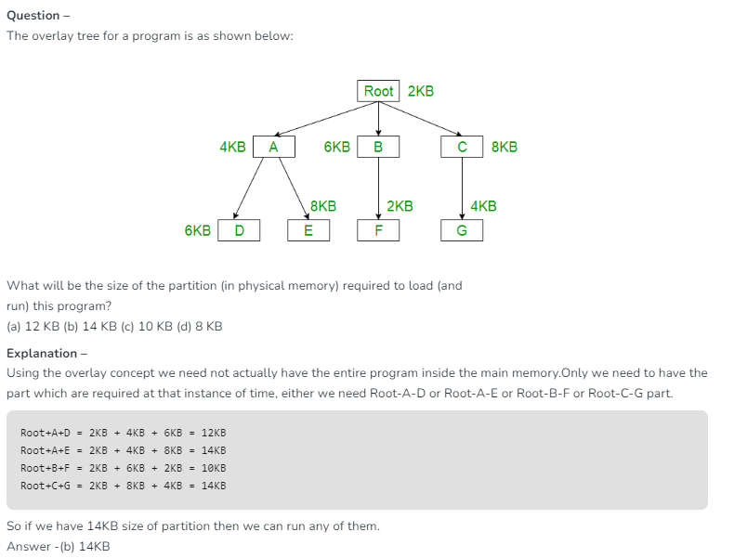
Non contiguous memory allocation: (spanning possible)
Program can be divided and then stored
Eg:
paging
Segmentation
//Watch video on logical address, physical address, frames, page tables
paging:
each process divided into pages and main memory is divided into frames such that
page size = frame size
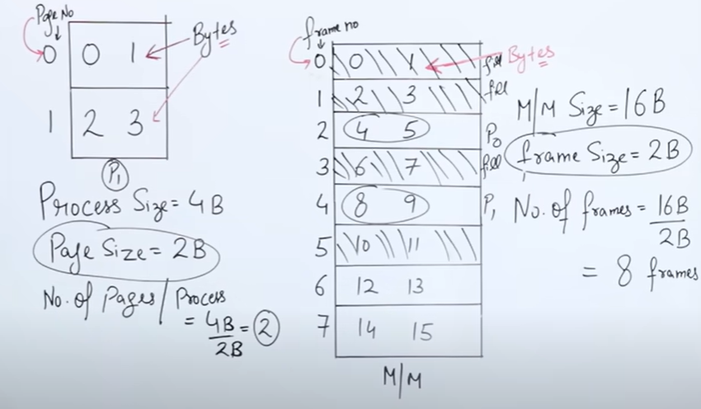
Memory is byte addressed
CPU generates Logical Address
Logical address = page_no + page_offset
No. of bits for page_no = logP where P=no. of pages
No. of bits for page_offset = logB where B=size of page in bytes
Physical address = frame_no + frame_offset
No. of bits for frame_no = logF where F=no. of frames
No. of bits for frame_offset = logB where B=size of frame in bytes
By using pagetable, logical address converted to physical address
(by using pageno we get frameno and frame_offset = page_offset)
Pagetable : it maps page number to the frame number
no. of rows = no. of pages
size of row = logN bits where N=no. of frames
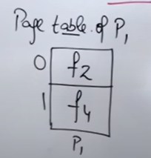
Multilevel page tables:
1.In order to access any frame using pageno we use page tables. This page table also should be stored inside main memory i.e frames.
2.Multilevel page tables are used when (size of page table) > (size of frame)
3.Here page table is split into parts so that size of each part = frame size and each part is kept inside a frame
4.Here firstly we create outer page table for which no. of entries are no. of inner page tables and each entry contains
the frame no in which corresponding inner page table is stored
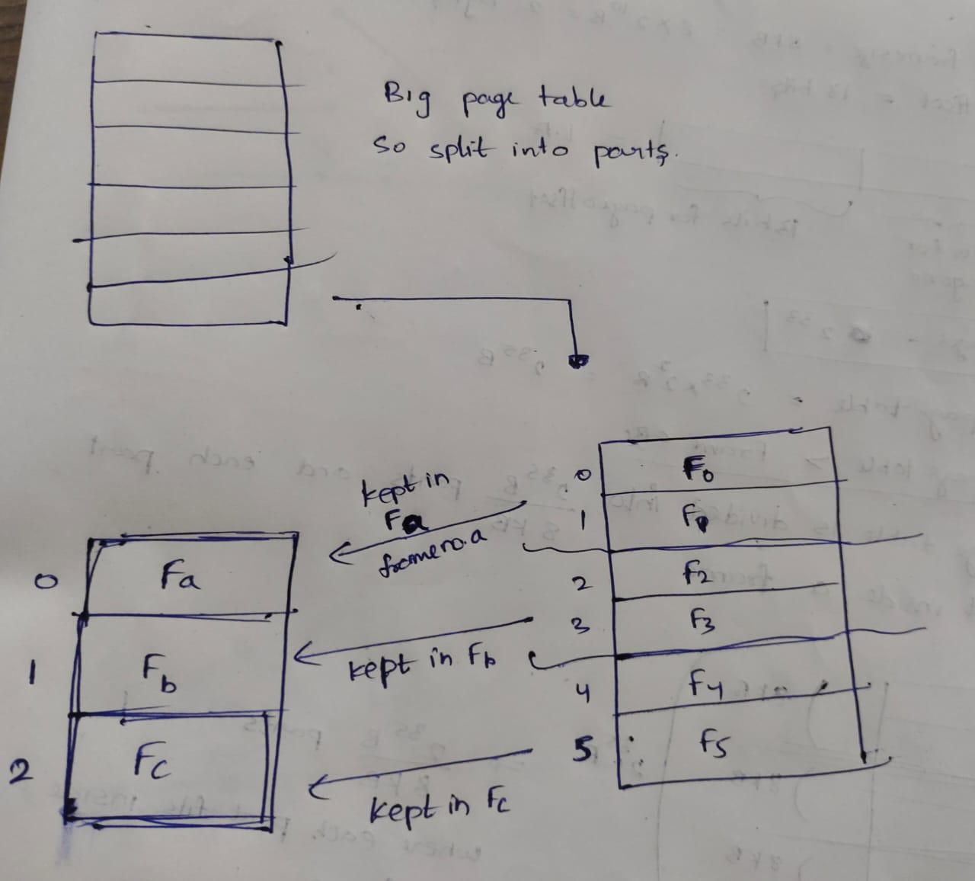

5.logical address also generated according to that
2^p1 = no. of entries in outer PT
2^p2 = no. of entries in inner PT
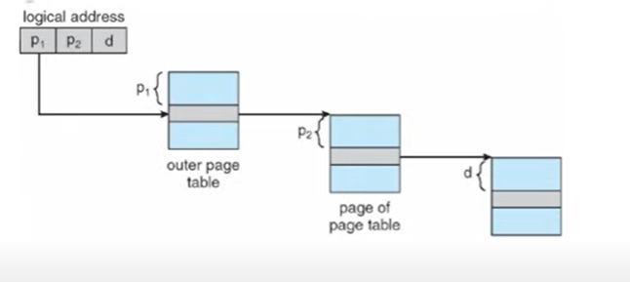
Ex:
Given pagesize = framesize = 8KB
Logical address or virtual address = 46bit
Page table entry size = 4B
How many levels of paging required
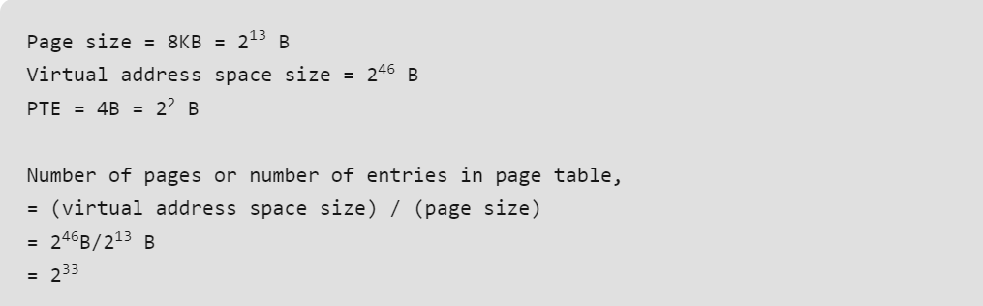
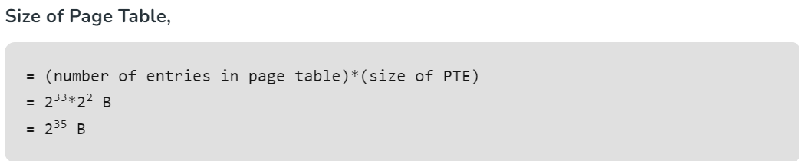
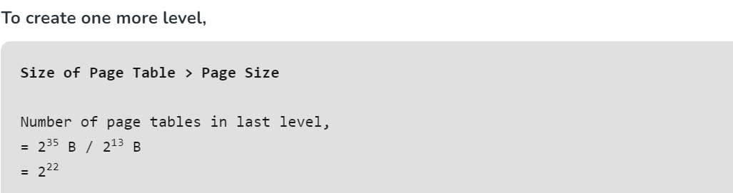
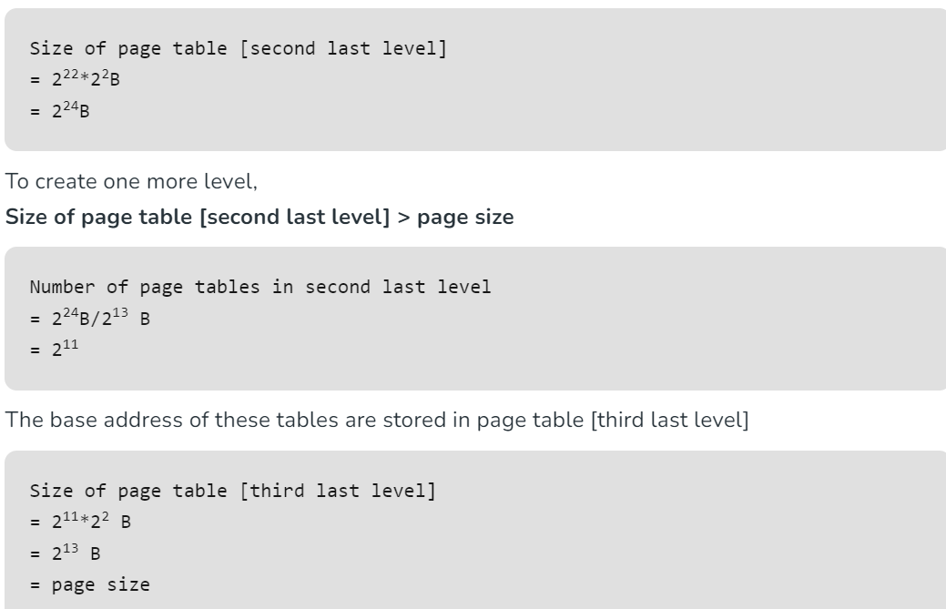

ex: pagetable entry size = 2B
No. of pages = 2^20
No. of frames = 2^16
Frame size = 4KB = 2^12bytes
from the given data size of page table = 2^21bytes = 2MB which is greater than 4KB
So no of entries in outer page table = 2MB/4KB = 2^21/2^12 = 2^9 (we are trying to make inner PT size as 4KB)
Now size of outer page table = 2^9 X 2B = 2^10B = 1KB which is less than 4KB so no problem
no of entries in inner page table = size of inner PT/size of each entry = 4KB/2B = 2^11
logical address = 20+12 = 9+11+12
Inverted paging:
in normal paging, lets consider there are 10 processes and even if a single page of each process is stored inside main memory, pagetables of the all the 10 processes should be stored inside main memory which uses more memory.
in inverted paging, there is a global page table for all the processes whose entries are PID, process state, frame no.
Using this page table frame number can be obtained
here disadvantage is more searching time.
Internal fragmentation is possible in paging.
Ex: Process size = 17KB and pagesize/framesize = 5KB
So process is divided into 4 bytes
4 pages = 4*5 = 20KB
20KB – 17KB = 3KB memory wastage

Segmentation:
A process was made into segments and each segment is having a meaningful data.
Ex:given code is divided into 3 segments as main( ), add( ) and subtr( )
Pages = equal size
Segments = unequal size

Segmentation table and logical address:
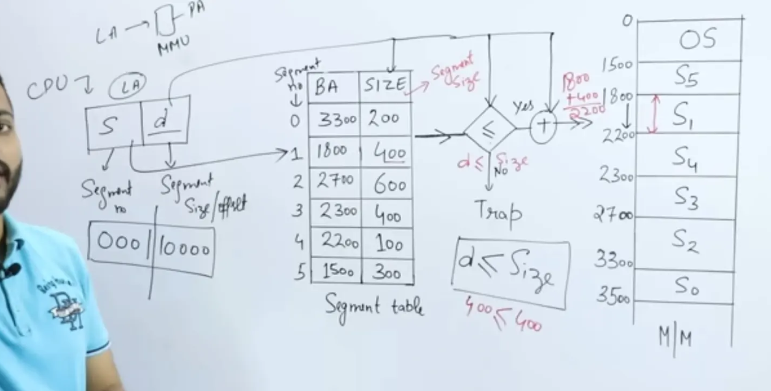

External fragmentation is possible in segmentation
Consider three segments of a process:
Segment A requires 8 KB
Segment B requires 4 KB
Segment C requires 6 KB
2KB free space next to Segment C
if segment B is removed, the free memory may not be able to accommodate a new segment that requires 5 KB

Virtual memory -
Virtual memory is a trick that makes your computer think it has more memory (RAM) than it physically does.
Implemented using demand paging
Demand paging: The process of loading the page into memory on demand (whenever a page fault occurs)
Firstly system refers the page table of required page from the main memory
By referring page table it will get to know whether required page is present in main memory or not
- If the required page is present in main memory then system directly refers main memory (page hit)
- If the required page is not found in main memory, it indicates a page fault, now system refers hard disk for the
page. Required page will be brought from hard disk to the main memory. Page replacement in main memory is
done using some PR algorithms. Now update the page table.
Let Main memory access time is: m
Page fault service time is: s
Page fault rate is : p
Then, Effective memory access time = (p*s) + (1-p)*m

Swapping:
Process of swapping pages between MM and hard disk during page faults

Thrashing:
the process of system spending more time in swapping data between MM and hard disk rather than executing the process.
Causes: High degree of multiprogramming. Insufficient MM, improper PR algorithms
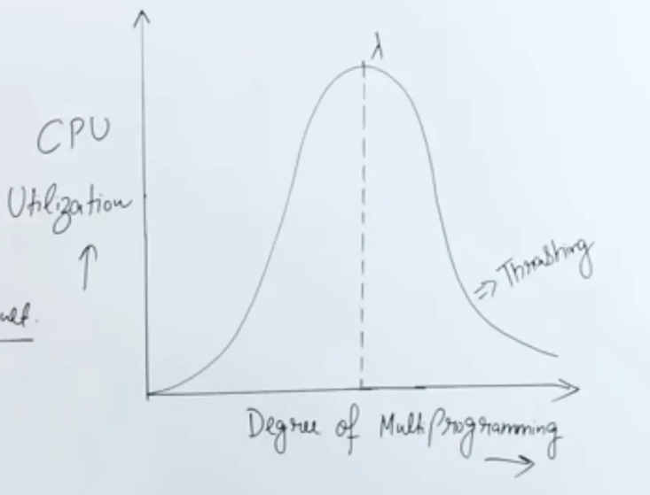
1.As we already know that CPU utilisation increases as more no. of processes inside main memory. Because during
I/O operation of a process, CPU will not be in ideal state it will execute next process in the ready queue.
2.But this phenomenon is only upto a particular instant. After this as no. of processes increases, CPU utilisation
decreases.
3.As there are more no. of processes inside the main memory, there is less probability that our required page from a
particular process is present inside the main memory as size of main memory is fixed i.e same in both cases.
4.The page of the required process that is present inside the main memory may not be our required page. So this
leads to page faults and system spends more time in swapping data between MM and hard disk rather than doing
executing a process.
5.Because of page faults effective access time of the process increases so that CPU utilisation decreases.
To avoid thrashing we have to increase the size of main memory. But this is very costly.

Page replacement algorithms:
FIFO
Optimal page replacement
Least recently used page replacement

Beladys anomaly in FIFO :
1 2 3 4 1 2 5 1 2 3 4 5
Hits 3 > hits 4

Translational lookaside buffer:
in case of page hit from page table the below formula
EMAT = h*(c+m) + (1-h)*(c+2m)
When CPU generates a logical address, firstly page table should be refered in order to get frame number. After getting the frame number we can access that particular frame from the main memory. As page table is also in main memory, effective access time for the CPU is 2*m where m is time to access main memory.
So inorder to reduce the effective time, most recently used page table entries are stored in TLB which is a special cache memory.
When there is TLB hit, the access time is c+m and in case of TLB miss and page hit the access time is c+2*m where c is time to access cache
Steps in TLB hit
- CPU generates a virtual (logical) address.
- It is checked in TLB (present).
- The corresponding frame number is retrieved, which now tells where the main memory page lies.
Steps in TLB miss
- CPU generates a virtual (logical) address.
- It is checked in TLB (not present).
- Now the page number is matched to the page table residing in the main memory (assuming the page table contains all PTE).
- The corresponding frame number is retrieved, which now tells where the main memory page lies.
- The TLB is updated with new PTE (if space is not there, one of the replacement techniques comes into the picture i.e either FIFO, LRU or MFU etc).

Cache:
Cache is a small, high-speed memory located close to the CPU
Cache stores this frequently used information so that the CPU can access it much faster compared to fetching it from the main memory (RAM).

Cache mapping : (Watch gatesmasher videos if time allows)
The process /technique of bringing data of main memory blocks into the cache block is known as Cache Mapping.
The mapping techniques can be classified as :
- Direct Mapping
- Associative
- Set-Associative

Disc scheduling algorithms:
First come first serve
Shortest seek time first
SCAN (goes upto end on one side)
LOOK(no need to go upto end on any side)

Spooling : (read gfg article properly)
Spooling simply stands for Simultaneous peripheral operations online
Spool (Buffer Storage): Spooling creates a buffer, usually in secondary memory (like a disk), where jobs are stored temporarily until the OS is ready to process them. This buffer is called a spool. It holds data from multiple tasks or devices that are waiting to be processed by a slower device.
Fast vs. Slow Devices: In the OS, some devices, like the CPU, work faster than others, like printers or disk drives. When a fast device (like the CPU) sends data to a slow device (like a printer), the data is stored in the spool. The CPU doesn't have to wait for the slower device to be ready—it can continue doing other tasks.
Job Queue: The spool acts as a queue where tasks are lined up. The OS manages this queue using a First In First Out (FIFO) strategy, meaning tasks are processed in the order they arrive. This keeps things organized and ensures no data is mixed or lost.
Handling Jobs: When the slow device (like a printer) is ready, the OS retrieves the next job from the spool and sends it to the device. While this happens, the CPU is free to handle other tasks, making the whole system more efficient.
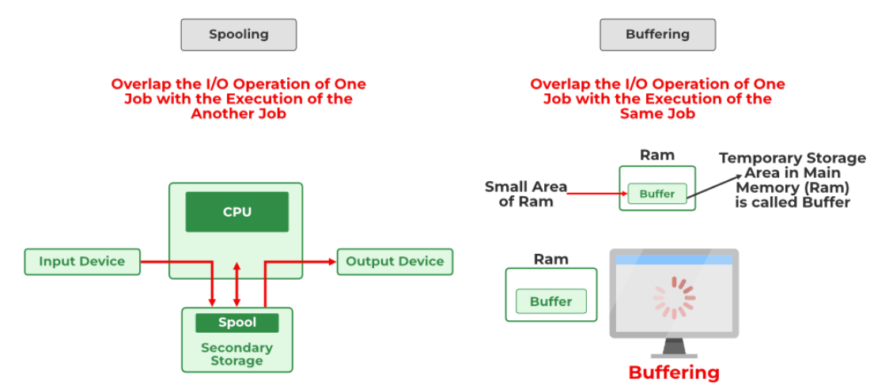
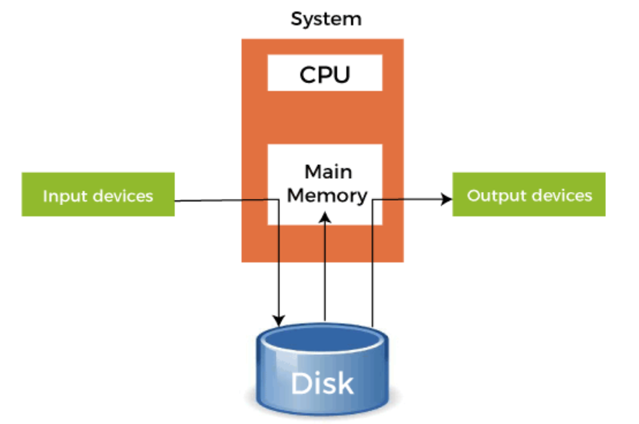

fork() :
1.The Fork system call is used for creating/duplicating a new process which is called the child process
2.After a new child process is created, both processes will execute the next instruction following the fork() system call.
3.The child process uses the same pc(program counter), same CPU registers, and same open files which use in the parent process.
It takes no parameters and returns an integer value.
Below are different values returned by fork().
Negative Value: The creation of a child process was unsuccessful.
Zero: return value of fork() for child process for successful child creation
Positive value: return value of fork() for parent process which is pid of child process for successful child creation.
Example 1:
int main()
{
pid_t p = fork();
if(p<0){
perror("fork fail");
exit(1);
}
printf("Hello world!, process_id(pid) = %d \n",getpid());
return 0;
}

Output:
Hello world!, process_id(pid) = 31 //parent
Hello world!, process_id(pid) = 32 //child
Or
Hello world!, process_id(pid) = 32 //child
Hello world!, process_id(pid) = 31 //parent
After the child process is created by fork(), both the parent and the child processes continue executing the program from the exact line where the fork() call returned.
1.When the parent process calls fork(), a new child process is created.
2.For the parent process, fork() returns the child’s PID (a positive integer).
3.The parent then checks the condition if(p < 0) (which is false for the parent) and skips over the error handling code, continuing to the printf() statement.
4.For the child, fork() returns 0, so the child also skips over the error handling code and moves to the printf() statement, just like the parent.

3 and 4 may occurs in reverse also.

Example 2: Calculate the number of times hello is printed.
#include <stdio.h>
#include <sys/types.h>
#include <unistd.h>
int main()
{
fork();
fork();
fork();
printf("hello\n");
return 0;
}

Output : (2^n times)
hello
hello
hello
hello
hello
hello
hello
hello

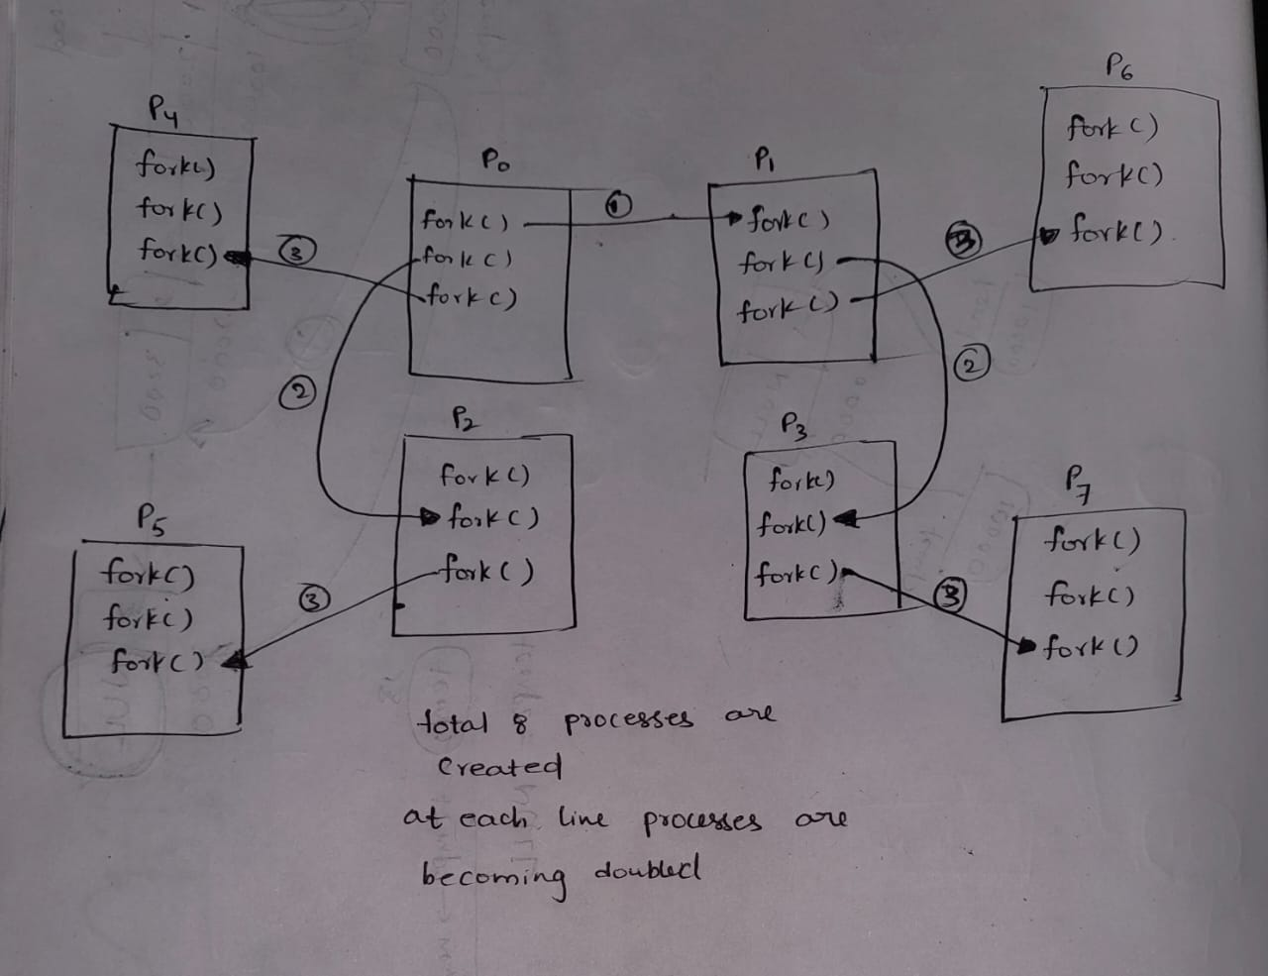

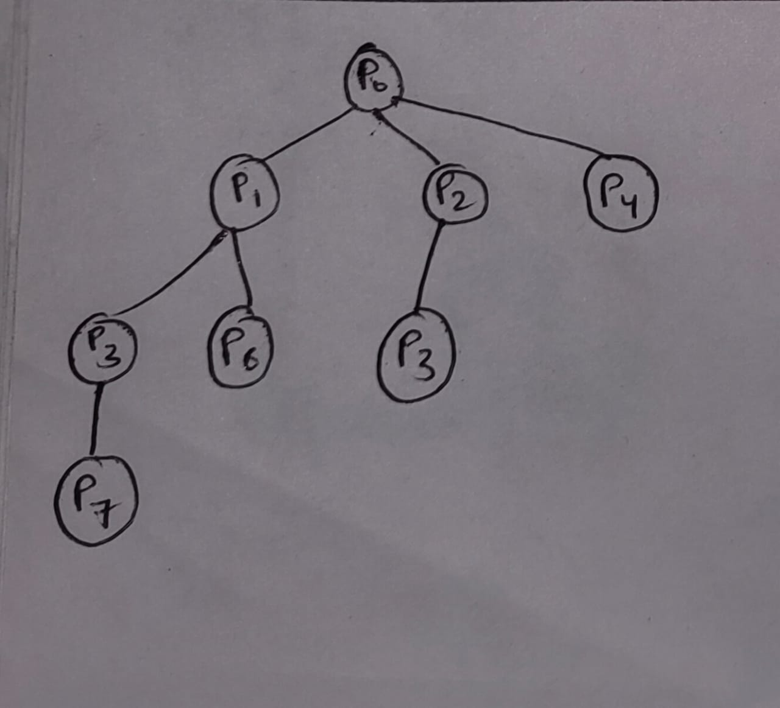

exit(): terminate the process
wait(): (if possible read complete article)
A call to wait() blocks the calling process until one of its child processes exits or a signal is received.
After the child process terminates, parent continues its execution after wait system call instruction.
Behavior of wait()
1.If the parent process has multiple children, the wait() call will cause the parent to wait until any child process
terminates.
2.If a child process terminates, wait() returns the PID of the terminated child.
3.If multiple child processes terminate, wait() will reap any one of them arbitrarily and return its PID.
4.If no children exist, wait() immediately returns -1.
int main() {
pid_t cpid;
if (fork() == 0) {
exit(0); // Terminate child
} else {
cpid = wait(NULL); // Reap parent
}
printf("Parent pid = %d\n", getpid());
printf("Child pid = %d\n", cpid);
return 0;
}
Output:
Parent pid = 32
Child pid = 33

Zombie process:
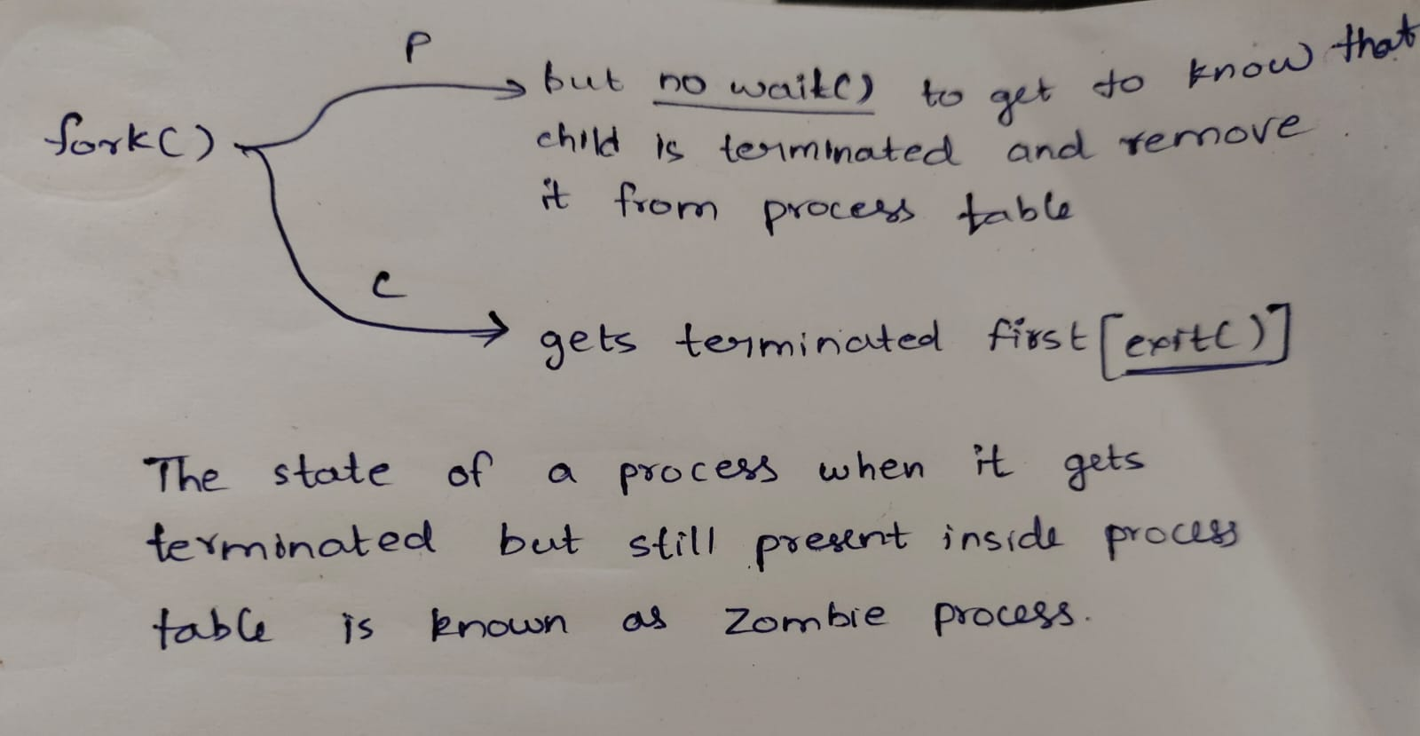
A child process which has finished the execution(resources are deallocated) but still has entry in the process table is known as zombie process
The parent process reads the exit status of the child process using wait(), and then reaps off the child process entry from the process table.
So, when parent don’t contain wait( ) to know whether child is terminated, it wont reaps off the child process entry from the process table which leads to zombie process.
int main()
{
// Fork returns process id in parent process
pid_t child_pid = fork();

// Parent process
if (child_pid > 0)
sleep(50);
// Child process
else
exit(0);
}
Here sleep for parent process is to provide enough sleep for parent to make sure that child will terminate before the parent’s termination

Orphan process:
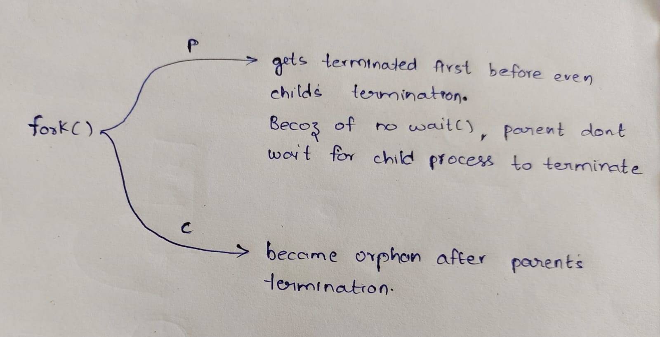
parent finishes execution and exits while the child process is still executing and is called an orphan process now.
However, the orphan process is soon adopted by init process(pid=1)
int main()
{
// Create a child process
int pid = fork();

if (pid > 0)
printf("in parent process");
else if (pid == 0)
{
sleep(30);
printf("in child process");
}
}

Here sleep for child process is to provide enough sleep for child to make sure that parent will terminate before the child’s termination

Reentrancy:
It is a concept from the olden days.
Reentrancy refers to a property of a program or function that allows it to be safely interrupted in the middle of its execution and then called again ("re-entered") before the previous execution is complete, without affecting the results of each other
Key Characteristics of Reentrant Functions:
- No Shared State Modification: Reentrant functions do not alter any global or static variables or shared memory. They operate only on data provided as input (e.g., function arguments).
- Local Variables Only: They use only local variables, which means each function call has its own copy of these variables, stored on the call stack.
- No Blocking Operations: Reentrant functions avoid using operations that may block, like I/O operations, because these can cause delays, making it harder for the function to be re-entered without issues.
Reentrancy vs. Thread Safety:
- Reentrancy is about making sure a function can be interrupted and resumed safely. It’s more relevant in single-threaded environments that use interrupts.
- Thread Safety is about ensuring a function can work correctly when multiple threads access it at the same time. It usually involves mechanisms like mutexes (locks) to prevent data corruption.
- A thread-safe function isn't necessarily reentrant. For example, a function that uses a mutex can prevent data issues in multi-threading. But if this function gets interrupted while it’s waiting for the mutex, it could get stuck (deadlock) when the interrupt tries to use it too.

Cascading termination:
It is a process termination in which if the parent process is exiting or terminating then the children process will also get terminated. It does not allow the child to continue processing as its parent process terminates. It is generally initiated by the OS.
This ensures that when a process ends, it does not leave its dependent processes (child processes) running, which could potentially result in orphan processes or other unintended behaviours.
RAID:
RAID (Redundant Array of Independent Disks) is like having backup copies of your important files stored in different places on several hard drives or solid-state drives (SSDs). If one drive stops working, your data is still safe because you have other copies stored on the other drives. It’s like having a safety net to protect your files from being lost if one of your drives breaks down.

- RAID-0 (Stripping) stripping means dividing into smaller pieces
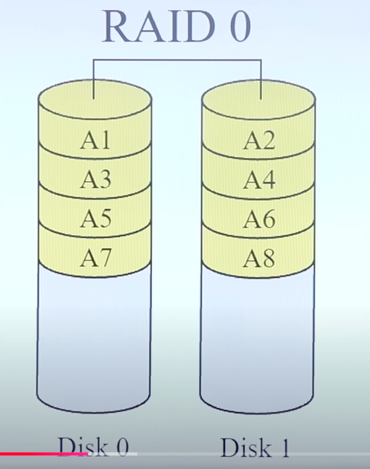

- RAID-1 (Mirroring)
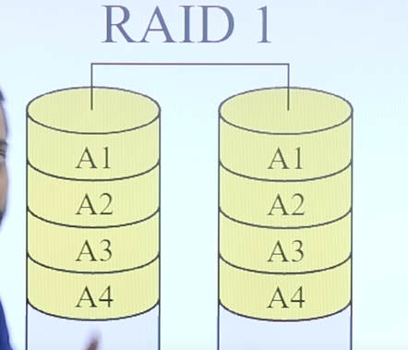

- RAID-2 (Bit-Level Stripping with Dedicated Parity)
- RAID-3 (Byte-Level Stripping with Dedicated Parity)
- RAID-4 (Block-Level Stripping with Dedicated Parity)
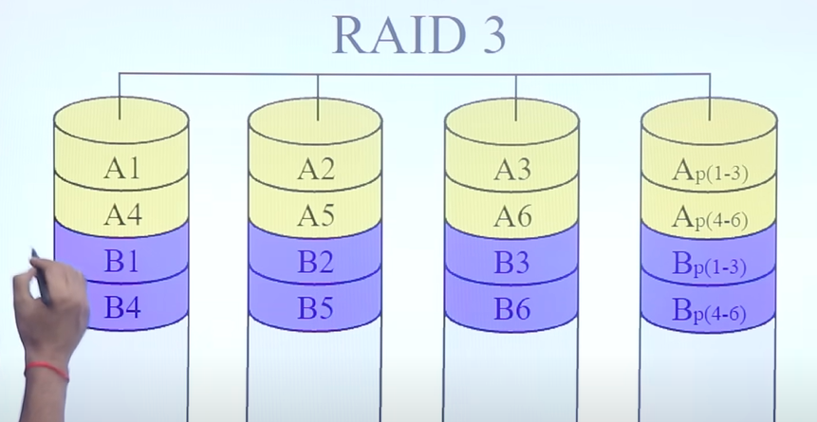
If A1 is lost, we can retrieve it back using A2 A3 and Ap(parity)

- RAID-5 (Block-Level Stripping with Distributed Parity)
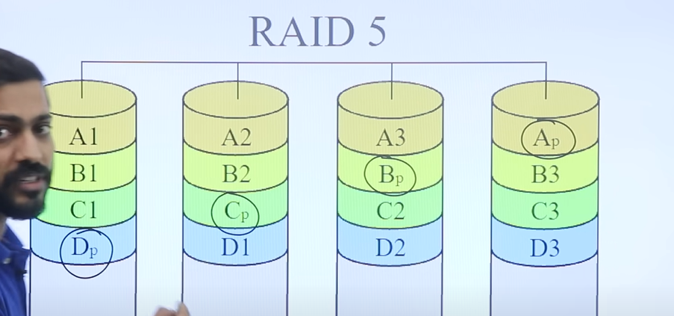

Types of OS:
1.Batch
2 Multiprogramming
3.Multitasking or timesharing
4.Real time OS
5.Distributed OS
6.Clustered OS

Assymetric clustering:
Starvation and aging : (convoy effect)
Real time OS:
Symmetric Multiprogramming:

Different types of kernel and difference between OS and kernel and difference between microkernel and monolithic kernel.

